Khan Academy Programming Test

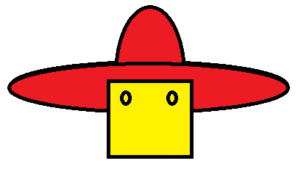

(10 Points) Write code to draw what’s shown above (a person with a hat). **NOTE: YOU DON’T HAVE TO MAKE THE EYES.**

(10 Points) Place this drawing code in a function that takes in x and y values as parameters (we’ve been calling them numX and numY, I think) and draws each shape using these parameters. Then, call the function twice to create two people. Show this before moving on.

(10 Points) Animate one person moving down the screen (i.e. falling).

(10 Points) Write code so that when the person gets to the bottom of the screen he or she reverses direction and move upwards.

(4 Points for an A+…) Add in gravity so that after the person “bounces” off of the bottom of the screen, he slowly starts reversing direction and eventually comes back down again.

Khan Academy Programming Test



(10 Points) Write code to draw what’s shown above (a person with a hat). **NOTE: YOU DON’T HAVE TO MAKE THE EYES.**

(10 Points) Place this drawing code in a function that takes in x and y values as parameters (we’ve been calling them numX and numY, I think) and draws each shape using these parameters. Then, call the function twice to create two people. Show this before moving on.

(10 Points) Animate one person moving down the screen (i.e. falling).

(10 Points) Write code so that when the person gets to the bottom of the screen he or she reverses direction and move upwards.

(4 Points for an A+…) Add in gravity so that after the person “bounces” off of the bottom of the screen, he slowly starts reversing direction and eventually comes back down again.